CAPSTONE PROJECT SUBMISSION DOCUMENT
Scenario 1:
project using Selenium with Java concepts (Implement TestNG with Page Object Model Framework) Implement mini project using Gherkin language
1. Launch a below URL and verify the title of the Page https://wordpress.org/
2. Do Mouse Over on Download & Extend and click on Get WordPress option
3. Verify the text in middle of the page as “Get WorkPress” using TestNG Assertions
4. Click on Community and click on Photo Directory
5. Search with any one of the pic name and verify the pictures are displayed

Note: Please implement below concepts as mandatory while designing this Case Study
1. Create a Maven Project and update POM.XML accordingly to implement this Mini Project.
2. Create a branch name – CapstoneProject_5 and implement your code in that branch. After coding is completed commit and push your code into that branch.
3. As implementing in POM design pattern, create an Object Repository package to track each and every page objects.
4. Create TestNG.xml and run the test cases from TestNG.xml
5. Use OOPs concepts to implement this framework and maintain Base Case separately
6. User TestNG Assertions to validate expected results how to check the results for this program in which folder or which file it will saving.

Overview:
This capstone project focuses on automating the functional workflow of the WordPress.org website using Selenium WebDriver with Java, TestNG, Cucumber (BDD), and Maven, while implementing the Page Object Model (POM) design pattern. The framework is designed with a clear separation of concerns, where web elements are maintained in an Object Repository, page actions are organized into dedicated page classes, and test execution is managed through a TestRunner integrated with TestNG. Test scenarios are written in Gherkin language to enhance readability and align with business requirements. Core OOP principles such as encapsulation, inheritance, abstraction, and modularity are applied to ensure maintainability, scalability, and reusability of the framework. The automation covers key functionalities including homepage title verification, navigation validation using mouse actions, content verification through TestNG assertions, and search functionality testing in the Photo Directory section. Overall, the project follows industry-standard practices and is structured to support future enhancements efficiently.
1.Validate WordPress Website Flow
1. Launch URL: https://wordpress.org/
2. Verify page title
3. Mouse over "Download & Extend"
4. Click on "Get WordPress"
5. Verify text in middle of page: "Get WordPress"
6. Click on "Community"
7. Click on "Photo Directory"
8. Search for any picture name
9. Verify pictures are displayed

2.Project Structure:
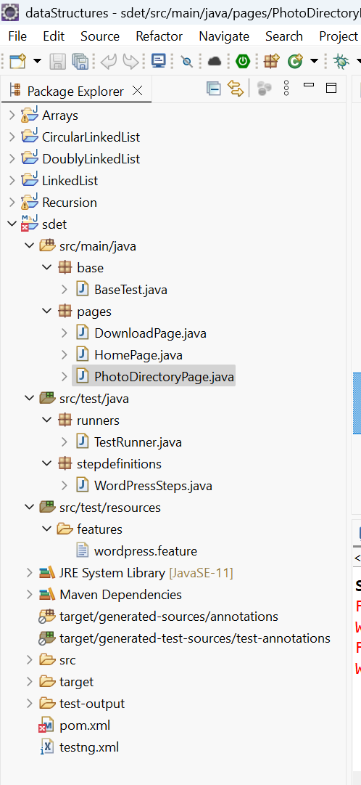

fig: Project structure IDE
3.Git Usage:
>> git init
>> git remote add origin
>> git checkout -b SDET
>> git add .
>> git commit -m "initial commit"
>> git push -u origin SDET
repo link: https://github.com/Chithrashree-P/SDET

4. Execution Report:
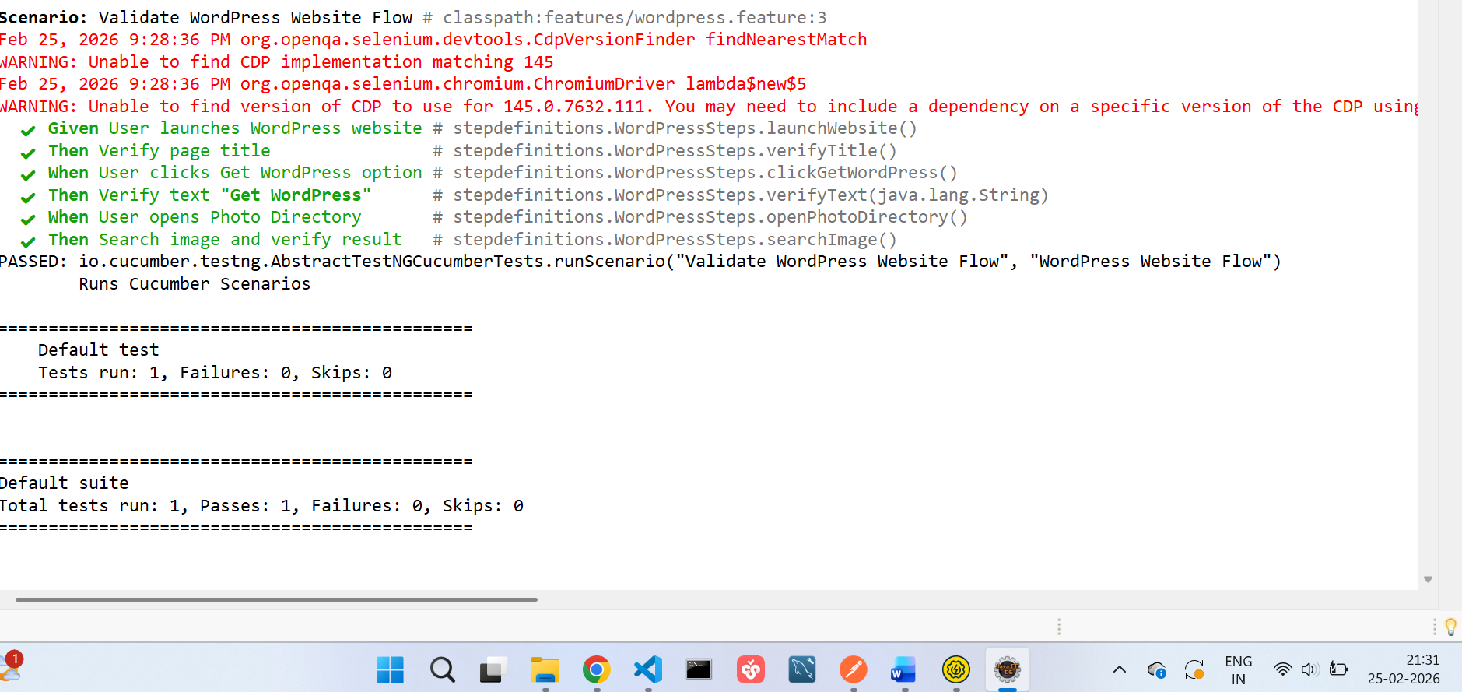
fig : Execution of the project and html report.

5. Gherkin Feature File
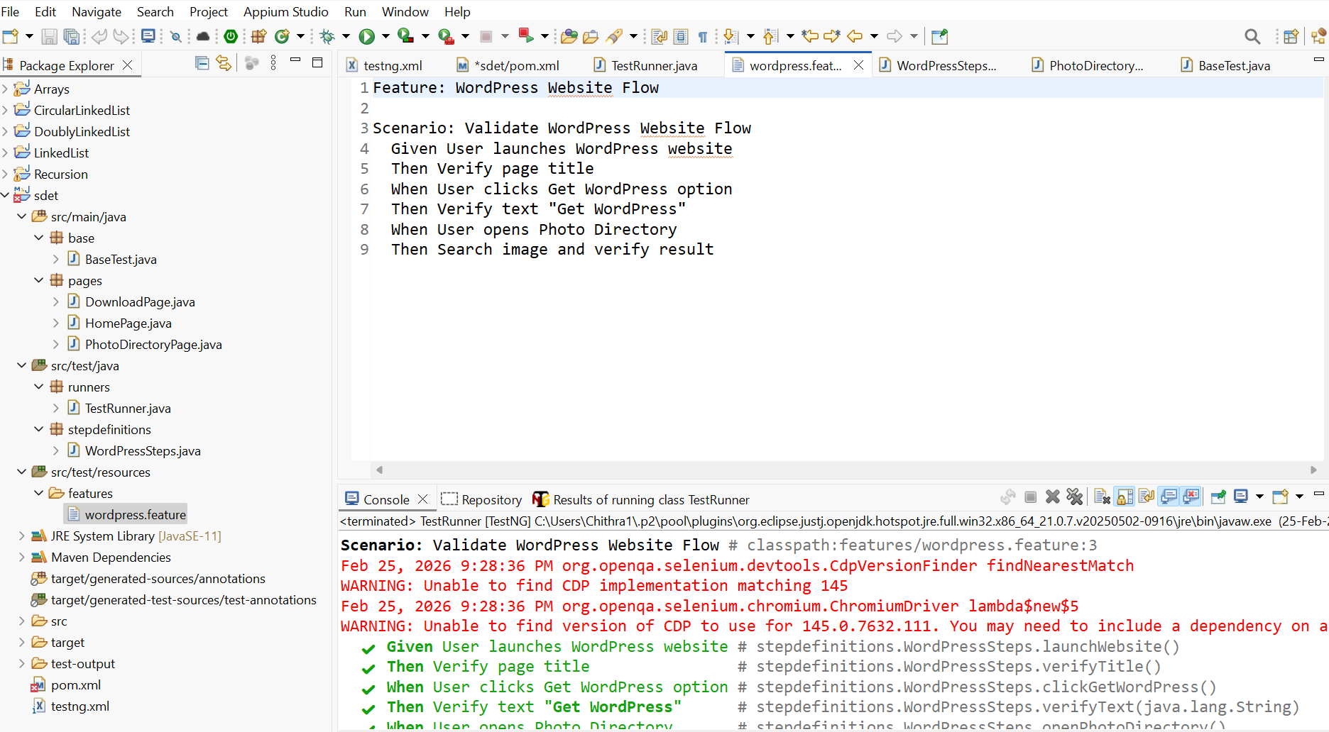

6. Output pictures for verification:
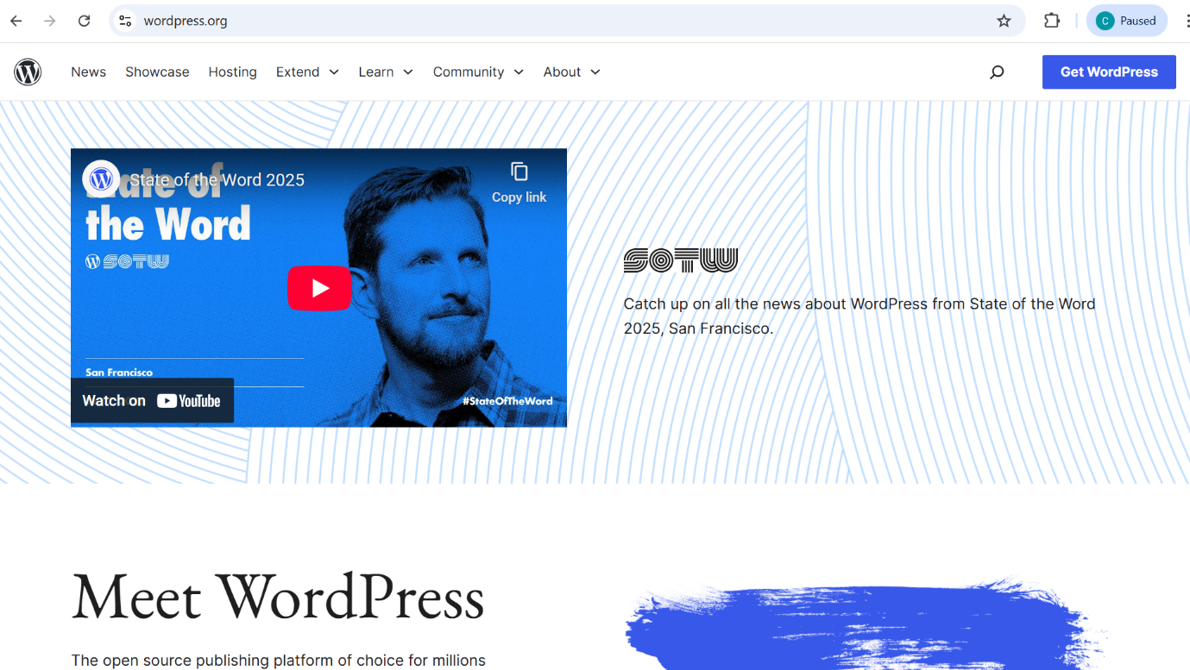
fig: Home Page
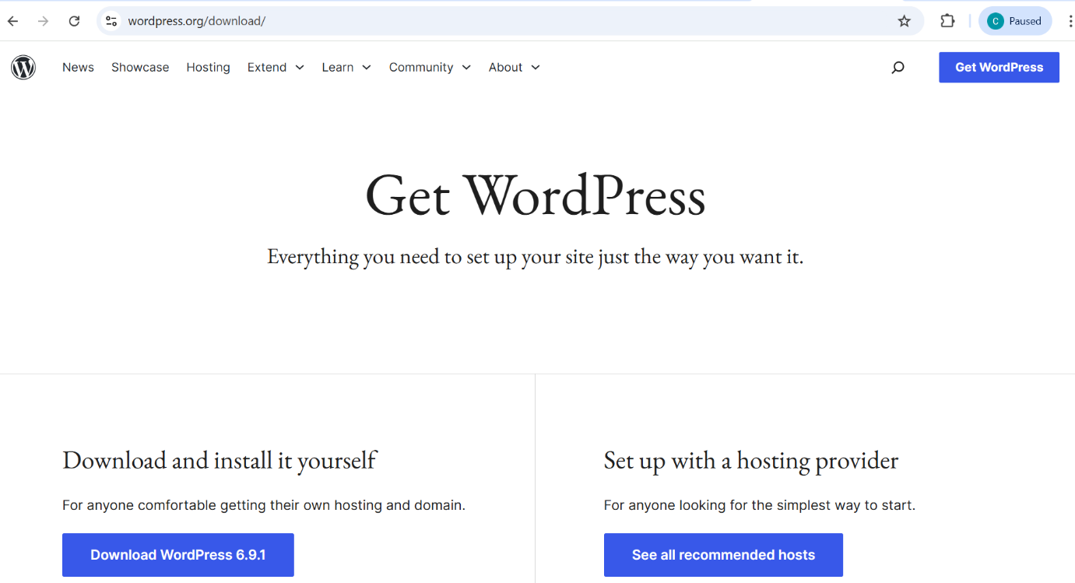

fig: Get WordPress Page
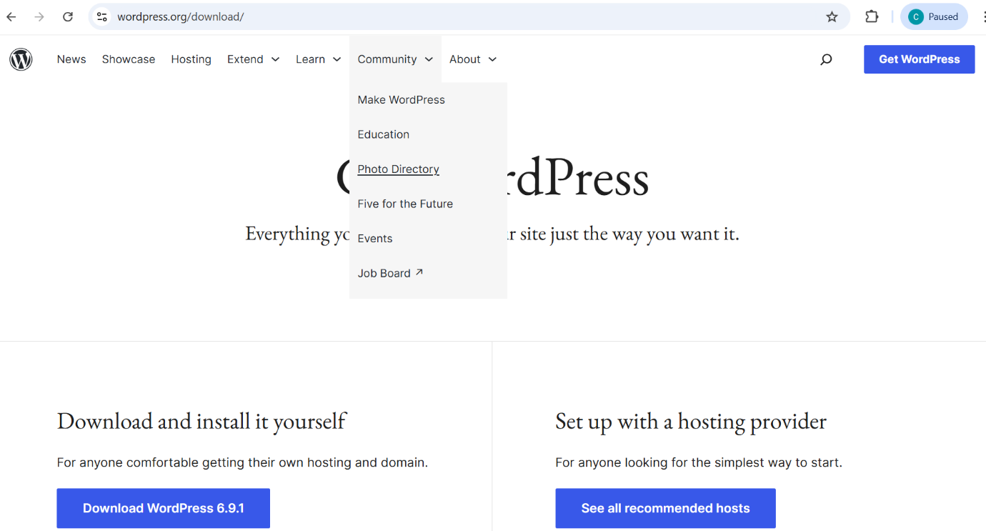

fig: Community & Photo Directory
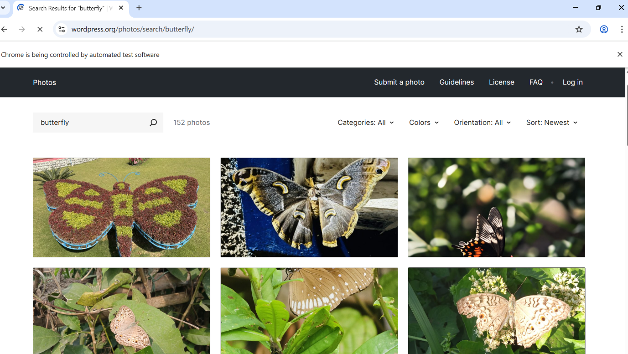
fig: Photos directory Page

Scenario 2:
Selenium Automation using Python & PyTest
● Project Title: Automation of WordPress Themes Search
● Objective: Automate WordPress theme search using Selenium, Python, and PyTest, including mouse hover and theme title validation.
● Tools & Technologies:
- Python 3.14 (Programming Language)
- Selenium WebDriver (Automation Tool)
- pytest (Test Framework)
- Google Chrome (Browser)
- Visual Studio Code (IDE)
- WebDriver Manager (Driver Management)
- Windows 11 (OS)
Project: Web Automation
Project Structure:
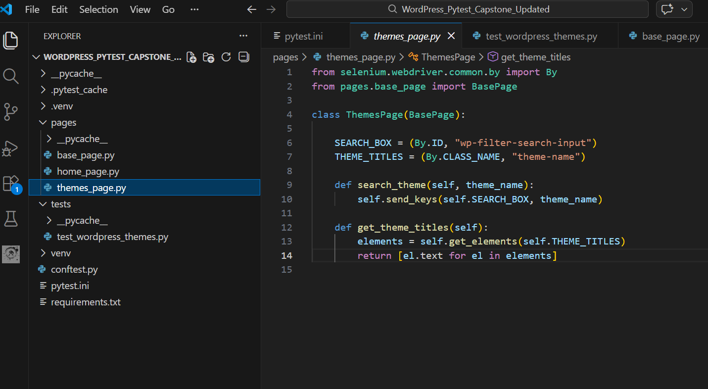
fig: File structure and code

Output Verification Image’s:

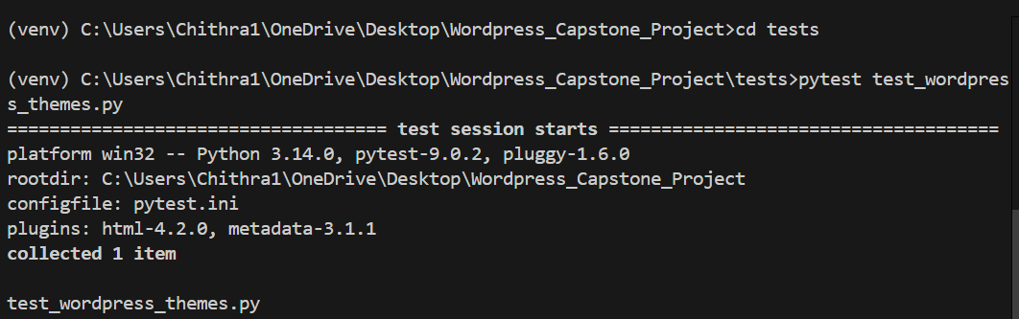
fig: Execution

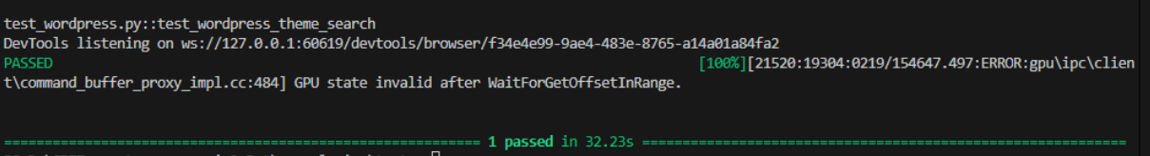

fig: Result

Scenario 3:
Implement below Case Study using POSTMAN API Automation
Create a SOAP Ul Project and Implement a generic function to read data from MS-Excel Sheets. And use get method to trigger an APl. (Use Groovy Script and SOAP Ul Assertions to validate the responses)
URL: https://restcountries.com/v3.1/subregion/{subregion} https://restcountries.com/v3.1/subregion/Northern Europe

Project Title:
API Automation Using Postman and SOAP UI with Excel
Objective:
To automate the REST API
https://restcountries.com/v3.1/subregion/{subregion}
using:
- Postman Automation
- SOAP UI
- Groovy Script
- Excel
- SOAP UI Assertions

Groovy Script:
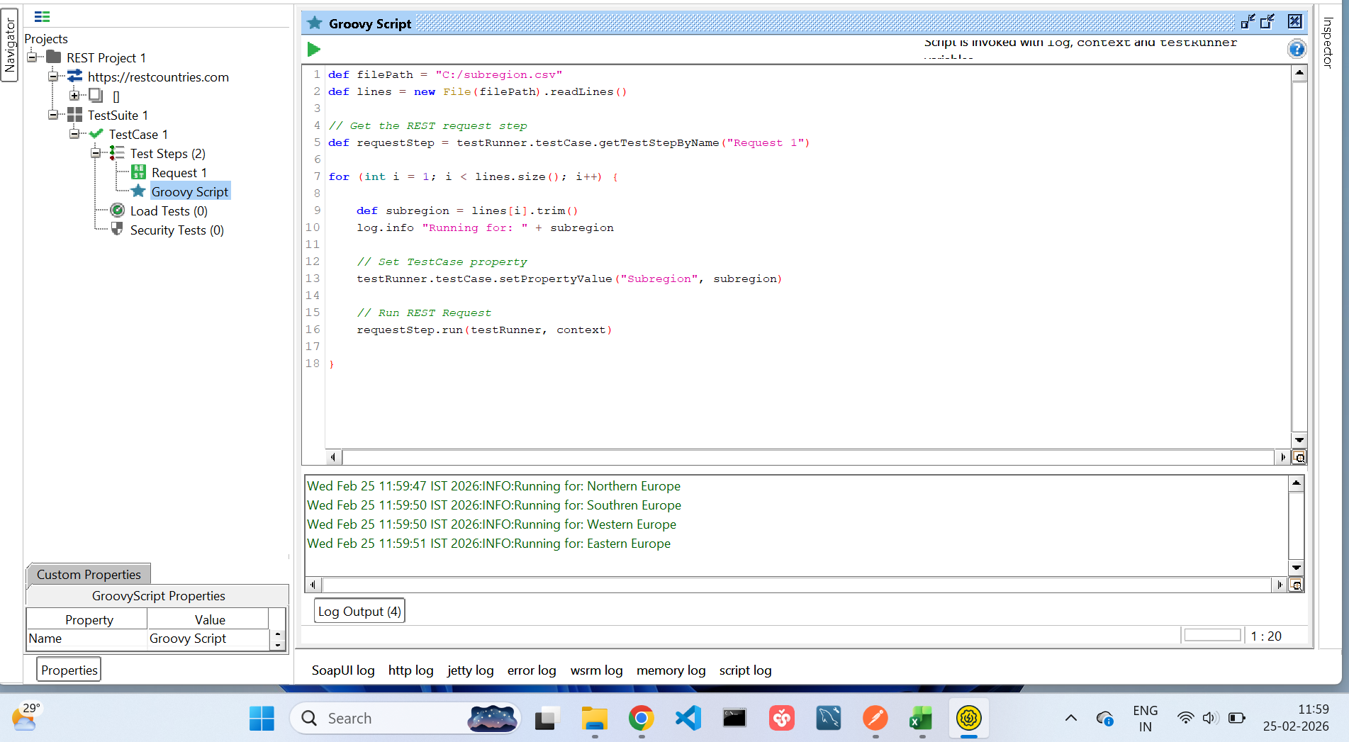

Request:
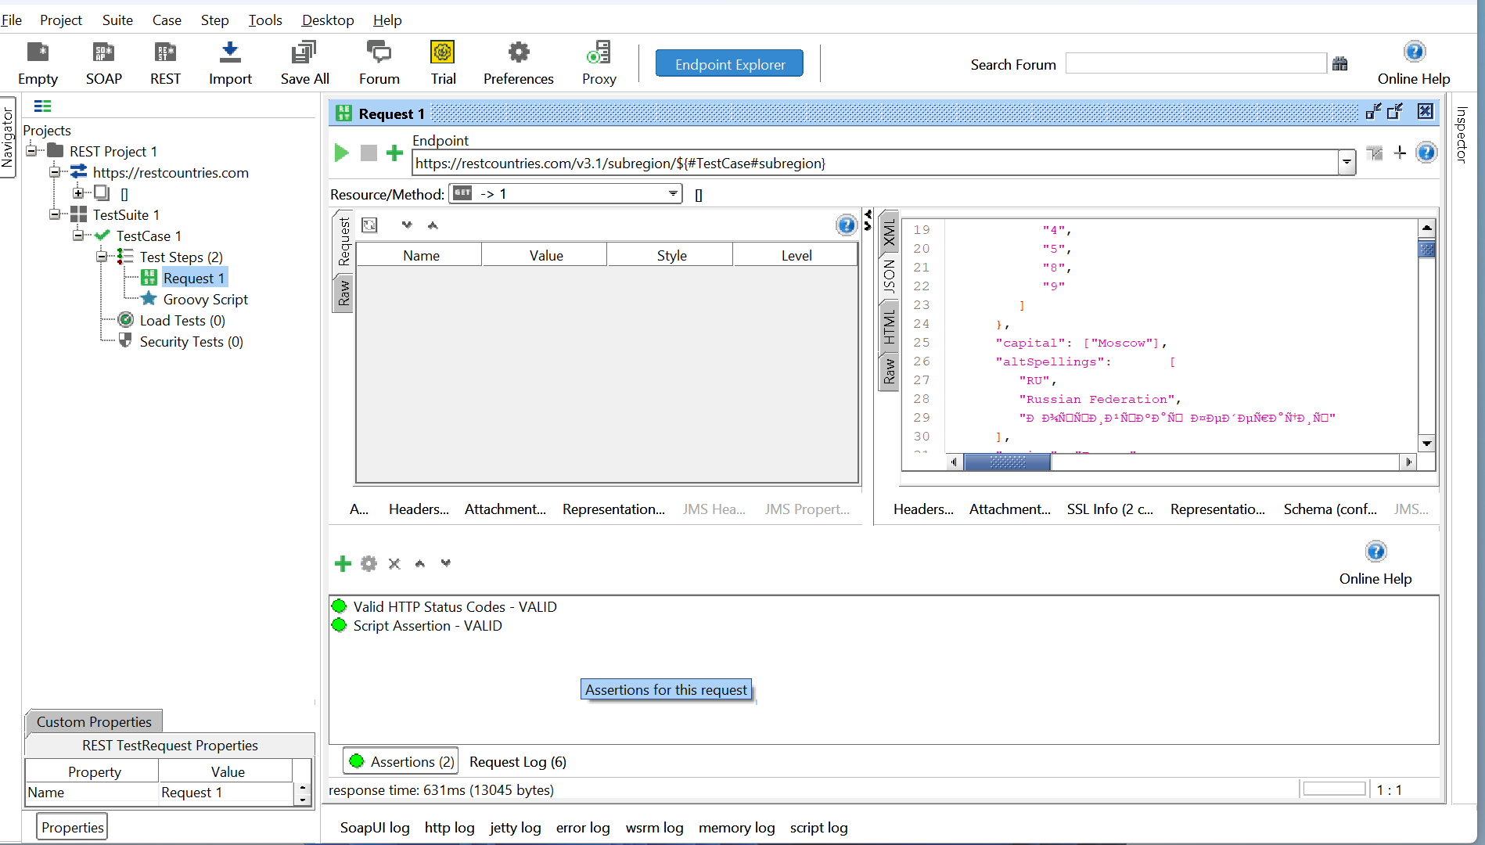

Excel sheet:
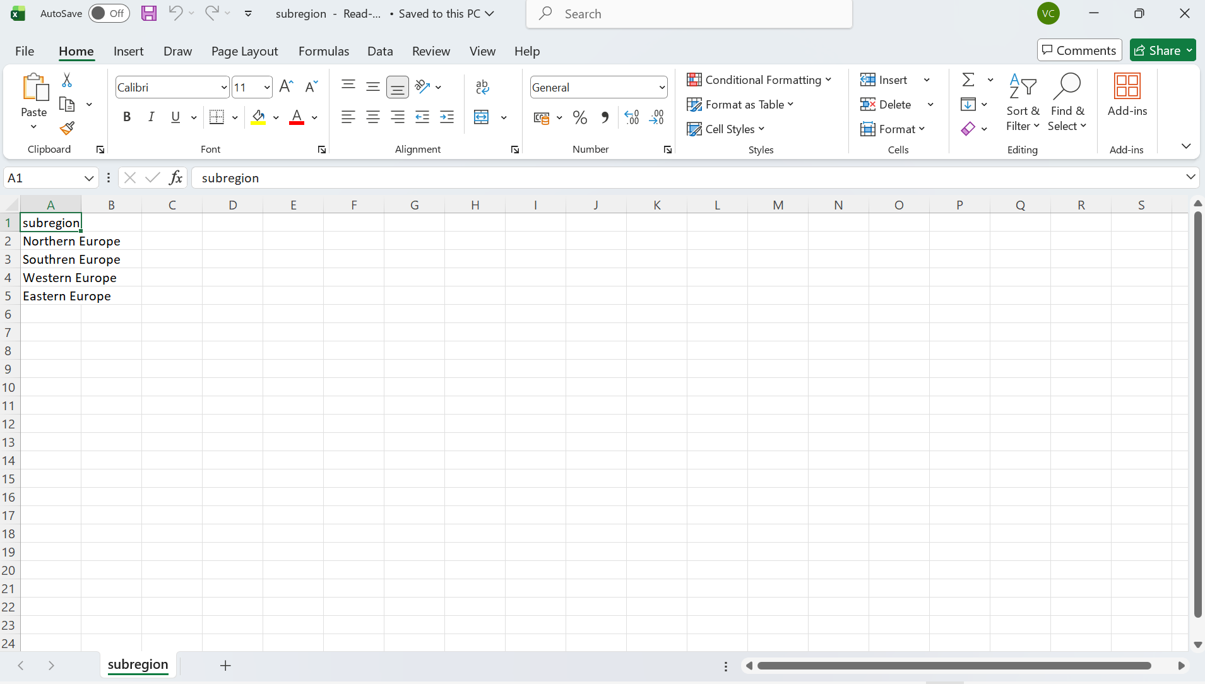
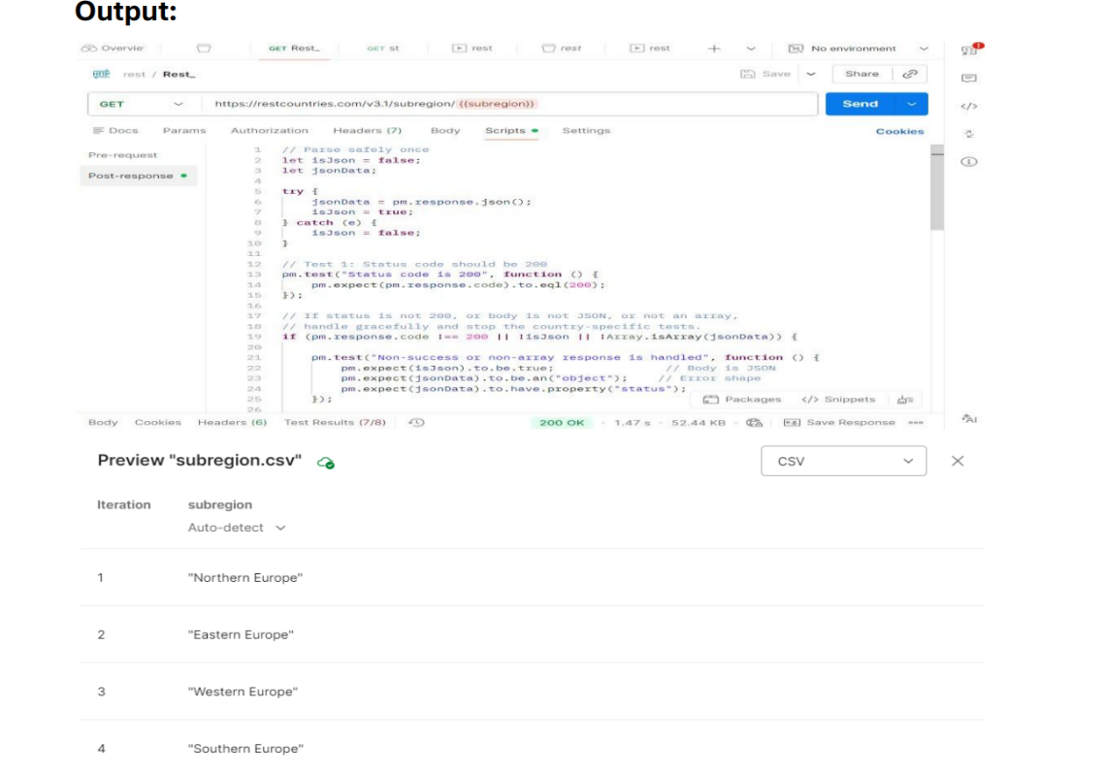

Chithrashree P
Emp ID: 8182621

